2 Minute Form
Trip Name | B.O.I. Paihia base camp | Date | Fri 24 –Mon 27 June 2016
Check-in Name | Ian Henderson | Check in Phone
  Mobile | 021 131 5513
  Work
  Home | 09 422 8944

Leaders | Ruth Henderson
Cell Phone Number | 021 298 8120
VHF Call Sign &/or Vessel Name | Rudolph ZMS4968
Vehicle make, model, registration, colour
  Make & Model | Toyota Corolla SW
  Registration | CFT 347
  Colour | silver
  Make & Model
  Registration
  Colour
General Plan  Used for Advertisement  Note: If plan changes, you must notify your Check-in person. | Enjoy Mid-Winter Solstice in the balmy Bay of Islands, based at a bach in Paihia. We will pick a paddle to suit the day, and can split into two pods for short or longer paddles. Paddling options include the Waikare Inlet (14 from Opua or 24 km from Paihia), Russell to Roberton Is (15km), Waitangi Treaty Grounds and Russell (14km), Black Rocks and Moturoa Island (19 or 26 km)...  Make sure you bring warm paddling clothes plus spares and Hi-Vis gear.  Plan B is to select sheltered paddling such as within the Waikare Inlet or Manawaora Bay. Plan C’s are unlimited....shops, café’s, tourist attractions.  Accommodation: Staying at a Bookabach in Paihia – booked for three nights for the price of two. To reserve your place you will need to deposit $62.50 (whether for 2 or 3 nights) into a bank a/c. Details emailed after your register. BYO linen= sleeping bag/pillow slip/tea towel. Be quick – limited to 12 beds.  Meals: DIY Fri night (plenty of take-aways, restaurants); Sat night: Shared pot luck dinner. Sun night : DIY
Time to Meet | ^{at bach on Fri night} | Time to be on the water | 9.00am
Latest Time Off the Water | ¹⁵⁰⁰ | TMP used²⁰ | New “B.O.I. Paihia” with 3 options plus Joya’s “Russell Camp” with 6 options.
Tide/ Forecast Lake Level | Low Sat 17.00 Sun 17.50  High Sat 11.00 Sun 11.45 | Other
Communications Carried²¹ | VHF, Cellphone
Communications | We will be communicating as a group on VHF Channel _8____
Equipment Carried | Usual winter paddle gear, spare warm clothes
No of Participants (taken from Club trip participate list)
Map
(route for trip – cut & paste)
Weather Forecast
(cut & paste from your weather forecast site

Trip Plan |  |  | B.O.I. Paihia base camp |  |  |  |  |  |  | Location |  |  |  |  | Paihia |  |  |  |  |  |  | Difficulty¹ |  |  |  |  |  | Strong beginner
Trip Description |  |  | Sea Kayaking |  |  |  |  |  |  | Leader qualification req.² |  |  |  |  | Sea kayaking
Get in Location |  |  | Paihia or Russell or Opua |  |  |  |  |  |  | Chart/ Map no.⁴ |  |  |  |  | Topo AV29, AW29, AV30 |  |  |  |  |  |  | Distance |  |  |  |  |  | 15 – 39km
Get out Location |  |  | As get-in |  |  |  |  |  |  | Coastguard Channel |  |  |  |  | 86 & 16 |  |  |  |  |  |  | Nowcasting |  |  |  |  |  | 21
Trip Destination(if different from get in get out) |  |  | Bay of Islands
Emergency get out ⁵ |  |  | Along coast, various islands |  |  |  |  |  |  | Emergency / Coastguard Station |  |  |  |  | Northland |  |  | Phone |  |  |  |  |  | *500 / 09 303 4303
 |  |  |  |  |  |  |  |  |  | Drinking Water⁶ |  |  |  |  |  | nil |  |  | Toilets⁷ |  |  |  |  |  |  |  | At launch site
Emergency Response |  |  | Refer Emergency Response Booklet |  |  |  |  |  |  |  |  |  |  |  |  |  |  |  | Parking⁸
Specific Equipment Required⁹ |  |  | Winter kayaking gear, spare warm clothes, Hi-Vis hat or flag or vest. |  |  |  |  |  |  | Working Communications equipment in this area¹⁰ |  |  |  |  |  | Cell phone |  |  |  |  | VHF Radio |  |  |  |  |  |  |  | PLB
Other resources  and notes¹¹ |  |  | BYO linen |  |  |  |  |  |  | Weather Parameters¹² |  | Beginner: no significant surf or swell, wind under 15 knots.  Intermediate: surf or ocean swells less than 1.5 metres or wind under 25 knots.  Advanced: any condition that’s suitable for the trip’s aims.
Previous incidents¹³
Safety Management¹⁴
Hazard |  | Significant?  - E/M |  |  |  | Management Strategy¹⁵ |  |  |  | Hazard |  |  | Significant?  - E/ M |  | Management Strategy¹⁵
Cold Water |  | Yes - M |  |  |  | Carry spare dry clothes and shelter |  |  |  | Deep Water |  |  | Yes - E |  | Correctly fit PFDs
Medical Conditions |  | Yes - M |  |  |  | - Leader has first aid qualification  - Ask customers about medical conditions |  |  |  | Bad Weather |  |  | Yes - M |  | Understand weather forecasts.  Have back up plans or pull out if necessary
Capsizing |  | Yes - M |  |  |  | - Correctly fit PFDs  - Skills at performing rescues. |  |  |  | Heat / Sun |  |  | Yes - M |  | - Protective Clothing (worn), Sunglasses, Hat  - Sun Screen  - Plenty of drinks
Panic |  | Yes - M |  |  |  | Ensure conditions match level  of skills |  |  |  | Obstacles |  |  | Yes - M |  | Awareness of reefs, navigational hazards, nets
Other Hazards |  |  |  |  |  |  |  |  |  | Other Vessels |  |  | Yes - M |  | - Understand the “rules of the sea”  - “Be seen” – Have two of the following; flag, brightly coloured kayak, brightly coloured Pfd or hat. At night: an all- round white light & a powerful torch.
Other Hazards |  |  |  |  |  |  |  |  |  | Other Hazards
Written up by: | Ruth E. Henderson |  |  |  | Approved By: |  | James Fitness |  | Signed: | jf |  |  | Date: |  | 11 May 2016 |  |  |  |  | Review in: |  |  |  |  |  | 12 months from date of approval
Additional Information Sheet (Optional)
Introduction (A general introduction)
Description (A description of the tour – as if you were selling the idea to someone)
Local Attractions |  |  |  |  |  |  |  | Transport/ Local Operators
 |  |  |  | Contact details |  |  |  |  |  |  | Contact details
Local Eateries
 |  |  |  | Contact details
Accommodation/ Campsite Locations |  |  |  |  |  |  |  |  |  |  | Facilities
Name |  |  |  | Mark |  |  |  |  |  |  | Cabins |  |  |  |  |  | Fuel |  |  |  |  |  | no
Phone |  |  |  | 021 741 1774 |  |  |  |  |  |  | Showers |  |  | yes |  |  | Power |  |  |  |  |  | yes
E-mail |  |  |  |  |  |  |  |  |  |  | Toilets |  |  | yes |  |  | Water Access |  |  |  |  |  | no
Website |  |  |  | Bookabach #10877 |  |  |  |  |  |  | Laundry |  |  | yes |  |  | Pool |  |  |  |  |  | no
Physical Address |  |  |  | Paihia |  |  |  |  |  |  | Water |  |  | yes |  |  | Fires Allowed
Other |  |  |  |  |  |  |  |  |  |  | Supplies |  |  | BYO |  |  |  |  |  |  |  |  | Shops nearby
Other information

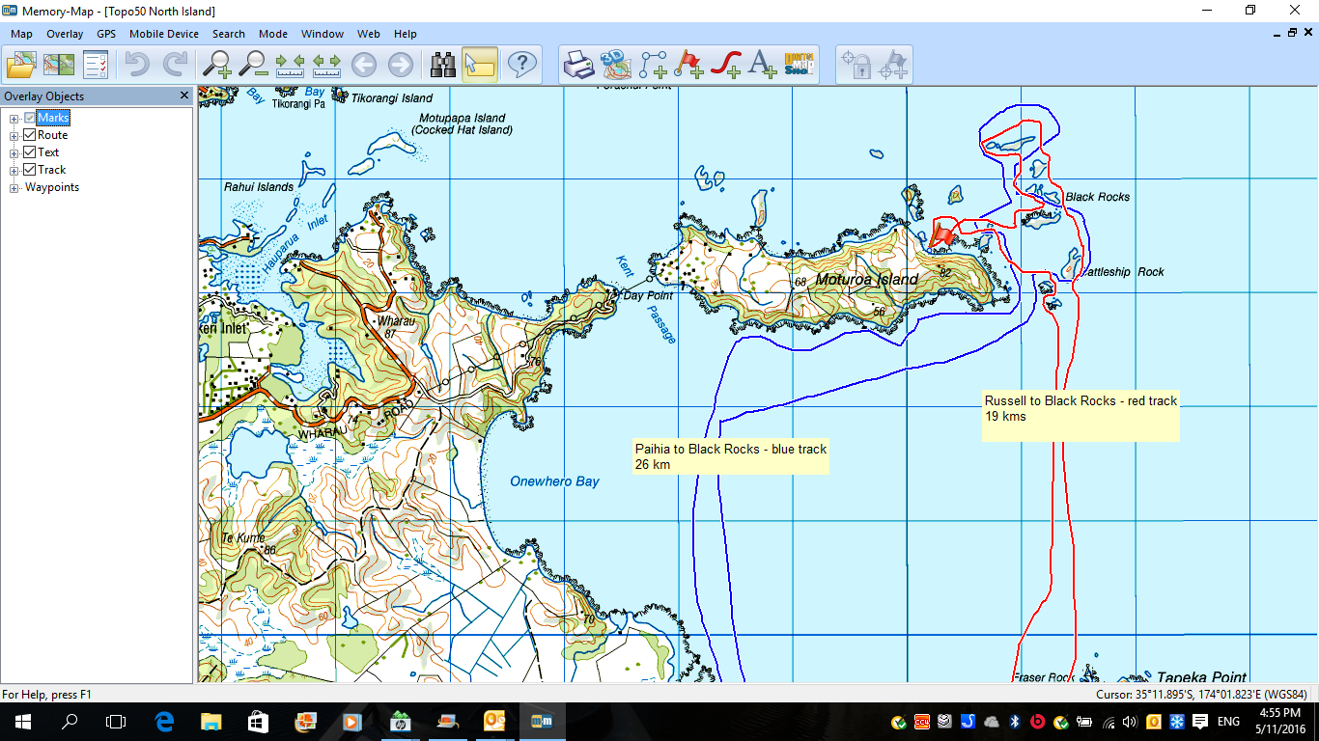
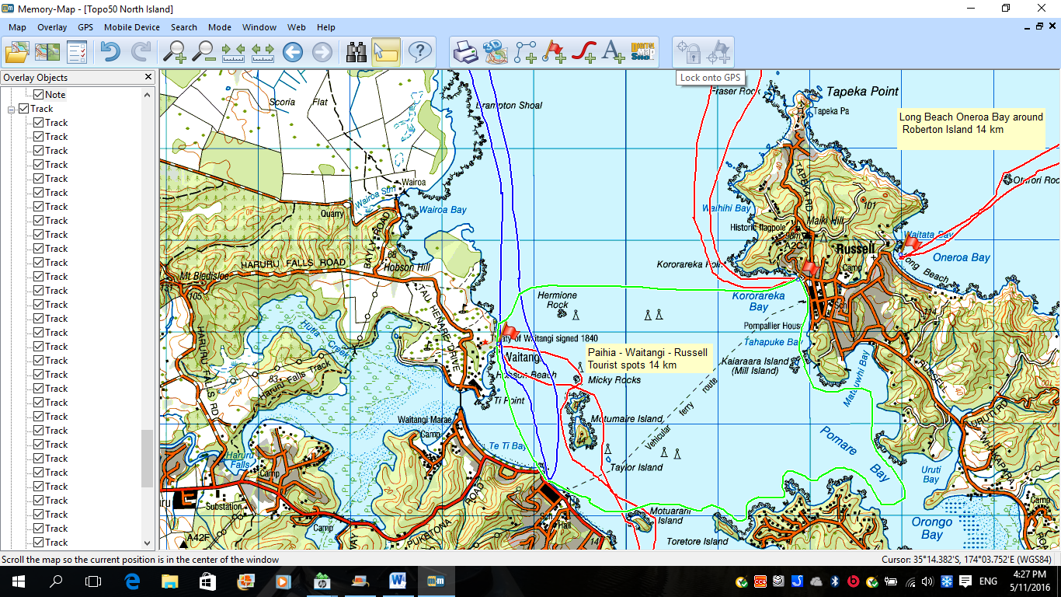

Long Bay, Russell to Motuarohia Is (Roberton Is) and circumnavigation 15 km

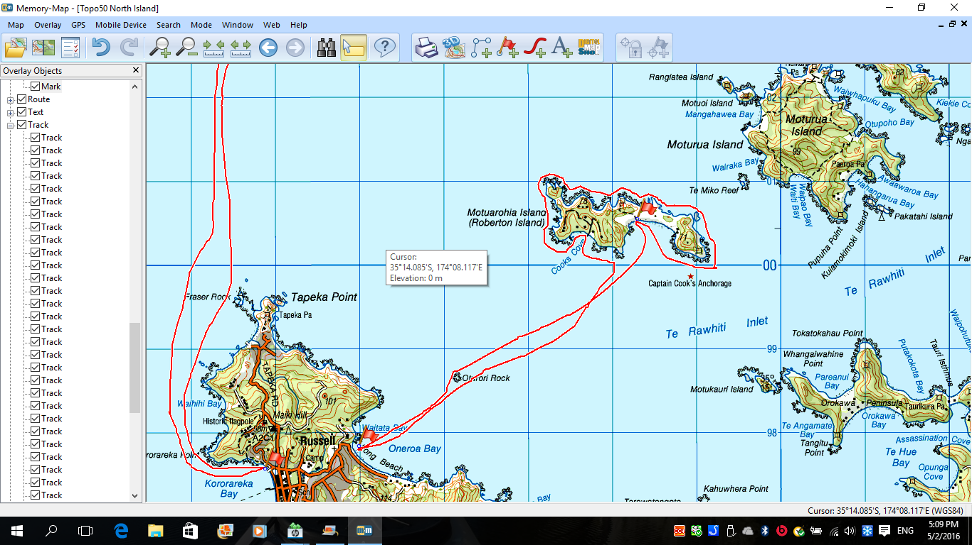
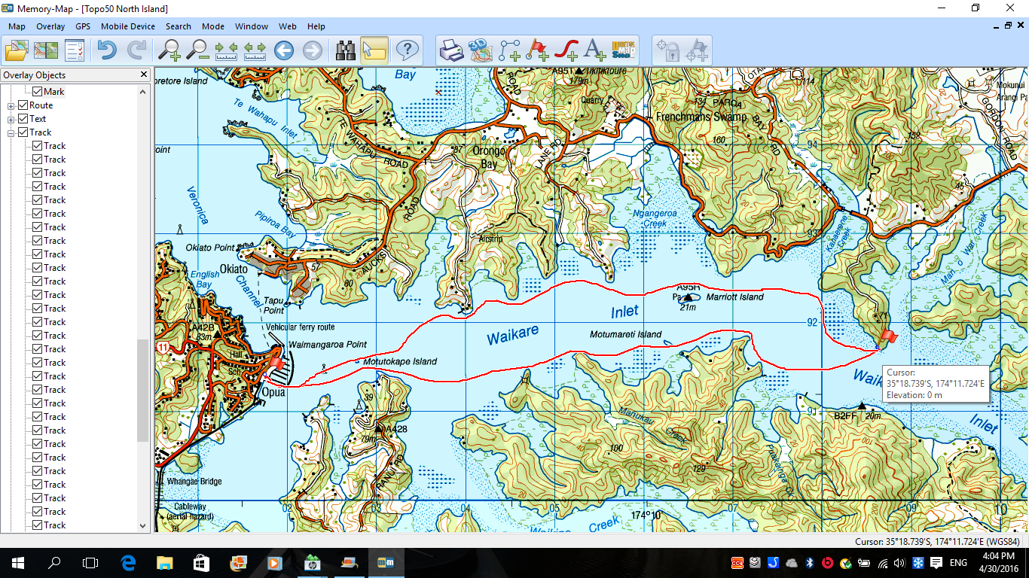
Opua to Te Ikaroa property in Waikare Inlet. Approx 7.5km each way = 15km.
Could also launch at Okiato opposite Opua or from Paihia (+ 10 kms).

Activity Equipment Check list
In case of emergency |  | Dial 111, Mayday :VHF Channel 16
Equipment Check  Yes / No | Equipment List | Group Gear Check  Yes / No | Group Gear
 | Helmet (rivers & surf) |  | Split paddles
 | Beanie / hat |  | Repair kit
 | Paddle Jacket |  | Fire lighting
 | PFD |  | Cooker/thermos
 | Spray deck |  | Tow system
 | Kayak & paddle |  | 1st Aid Kit
 | Booties |  | Flares
 | Thermals |  | Compass
 | Water & food |  | Charts / Maps
 |  |  | GPS (optional)
 |  |  | Knife (cut rope)
 |  |  | Emergency Shelter
 |  |  | Spare thermals
Yes / No | Kayaking Check list | Yes / No
 | Trip plan |  | Emergency Procedures include emergency get out.
 | Trip Plan/ 2-minute form lodged with Ops. Manager |  | Working communication devices e.g. VHF radio, mobile phones, PLB
 | Latest weather forecast |  | Specific safety issues for this trip
 | Conditions match skills? |  | Participant list
 | On & off water safety |  | Any medical conditions
 | Environmental concerns |  | All participants keen to proceed?
 | Hyperthermia (hot) & Hypothermia (cold)
 | Appropriate wind conditions to run trips
 | Novice - no significant surf or swell, wind under 15knots
 | Intermediate- surf or ocean swells less than 1.5 metre or wind under 25 knots
 | Advanced- any condition that is suitable to the trips aims
Yes / No | At conclusion of trip
 | Contact check in person
 | Group Debrief

Post Trip check List
To be filled out before, during or after the trip
Yes / No | Activity reports. Is all relevant information present
 | Approved Trip Management Plan (TMP)
 | 2 MINUTE FORM
 | Weather forecast
 | Club Trip Participant Sheet
 | Activity Check List
 | Trip report (May be on the 2 minute form)
 | Accident / incident reports
 | Trip Report (anything you want to report back to Club)

Leaders Signature
Date

